|  |  |
| --- | --- |
| **#STOP THE CRUELTY #WELCOME REFUGEES**  **7 YEARS TOO LONG!**   1. **NUMBERS remaining in PNG. 181 refugees or asylum seekers.** 2. 37 flew to the US two months ago and eleven more will fly out on Tuesday. 3. The fate of about 50 waiting on an answer from the US is unknown. Some have had medicals ready to depart, others have had no answer. 4. About 40 are those who were imprisoned in horrific conditions in Bomana gaol for months are being processed by UNHCR for resettlement in Europe, US, or Canada. They will NOT be part of the Canadian Sponsorship Program and we hope they will gain their freedom soon. 5. About 10 are too ill to travel or be resettled and will need hospitalisation and long   term support. Will not apply for sponsorship this year at least or maybe ever.   1. About 70-90 others remain in PNG with an uncertain future.   **NAURU**: 180 others wait on Nauru with little hope  **Special Thanks and appreciation to those who send donations or phone credit.** Some send monthly and others send when they can. You have no idea how much difference this makes. So often we have to say NO to desperate requests but because of your generosity we can often say YES. I apologise for not responding and thanking you and giving more news this year. I have to admit I have been a bit burnt out and haven’t managed to get to it. Jane    **DONATIONS still needed and appreciated:**  **BRIGIDINE Sisters BSB 112879**  **Account number 010449549** | **Manus Lives Matter**  **Breaking, Broken, and Crying for Freedom**  **Newsletter AUGUST 2020**  ***In this Issue:***   1. ***Our Manus friends now in Moresby need support*** 2. ***Ex Manus locked up in hotel rooms 10 months now*** 3. ***Costs of locking people up*** 4. ***US resettlement- the good and the less good*** 5. ***Canada Sponsorship- a major drive*** 6. ***Don’t take away their PHONES drive***   **MORESBY- What is happening?**  **Mental Health** is at all all time low and this is the main reasons we need donations to help them survive. After months deprived in their rooms an occasional taxi trip to the shops can lift their spirits and they can get personal items they are lacking. Fresh food like apples or any fruit is out of their affordability so they have little diet choice.  Most live in **hostel type accommodation** in different parts of the city. Covid19 has meant they are in part lockdown and worried because of their vulnerable health state.  Recently thee have some attacks and one man was badly beaten, his cash and phone stolen. We are constantly having to **replace phones** worn out now or broken over many years in tropical humidity.  A few recently got the **bad news** they are ineligible for Canadian sponsorship- this was their last hope. Others need clothes  MLM still sends **monthly phone credit to about twenty** eighteach month and occasionally extra for special needs.  There are about **30 babies** in PNG born to refugees and local girls. These babies are stateless with no rights and poverty means families mostly do not have enough to live on. Some fathers are already in the US while others have chosen to stay in Moresby. Caritas and Fr Giorgio help with a little money for each family. Sickness or unexpected needs are a problem. Everyone around is very poor so help is limited. |

**Operation Not Forgotten Canada MOSAIC Sponsorship Authority**

**It takes two years too long to get sponsorship to Canada through this community program.**

**But it gives them some hope when otherwise there is nothing!**

Thanks to so many generous people in Canberra and across Australia and to MOSIAC in Canada and the Refugee Council of Australia working hard to get corporate sponsorship nearly $2m has been raised, enough to sponsor the first 100 or so refugees and their extra 50 or so dependents still back in their home countries. 65 men have passed the first steps towards a visa are working to make it another 50 by the end of this year.

We have to wait on the Canadian government to allocate spaces.

A team of 17 wonderful and trained volunteers here in Canberra work with MOSAIC to prepare the applications. Our three coordinators meet with MOSAIC in Canada for a Zoom meeting every week. Special thanks to Robyn Fetter who works almost full time and coordinates the volunteer work. Priority is for those still in PNG or Nauru but we have included some of the most traumatised and earliest applicants detained here in Australia.

**Cost of Australia’s punitive refugee policies**

According to figures compiled by the Refugee Council of Australia and published in March 2019, in the previous financial year the annual cost of detention per person was as follows:

• more than $573,000 a year to hold an asylum seeker in offshore detention;

• more than $346,000 to hold them in detention in Australia;

• $103,343 for an asylum seeker to live in community detention in Australia; and

• $10,221 for an asylum seeker to live in the community on a bridging visa while their claim is processed.

The Department spent $111 million on legal costs to challenge positive decisions for asylum seekers in 2018-19.

The report built on a 2016 publication by UNICEF Australia and Save the Children stated that Australia's policies of onshore and offshore detention, and of turning back boats, had cost $9.6 billion between 2013 and 2016.

The cost of offshore processing over the next three years in $1.2bn and $573,000 each person each year- on top of the $9bn spent on offshore and onshore mandatory detention between 2018 and 2020.

**Make your voice heard**

**Talk to your family and friends. Tell them why this issue is important to you.**

Please write to politicians, phone their secretaries. You do not need to go into long arguments. Just give your name and why you are concerned and ask that your message to the politician be put on record.

Watch your local Refugee Support Groups and go to any rallies. The men on Manus take great heart from seeing the support we give. They watch every facebook post for pictures of rallies and activities. Make the government accountable for the spending of this money on torturing innocents.

**DO NOT GET TIRED! DO NOT LOSE HEART ! YOU ARE NEEDED!**

**We may not protest because we know this will change the government. We need to protest so that the government will not change us.**

**Help Stop Dutton taking away mobile phones**. Above all phone or write to politicians to object to the new Bill before parliament that will give Dutton the power to take their mobile phones away. All ABF have go do will be to claim, without proof that the guys are a “danger” to health or safety. But the phones are the only way the men can prove now what the guards do to them and their own innocence over accusations. Already men have been put in isolation and moved to different locations for making complaints or speaking to media.

**The reopening of Christmas Island is a horrific move**. The government says it is only for criminals and not for our refugees but Dutton has criminalised innocents before and there is no excuse for locking up people who have finished their sentences and paid for their often less serious crimes.

**For contact details of politicians and newspapers and ideas for letter writing or phone calls contact Eileen O’Brien who faithfully runs our RAC Canberra letter writing group. eileensus@gmail.com**

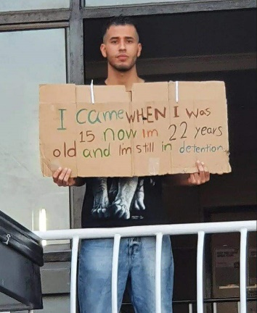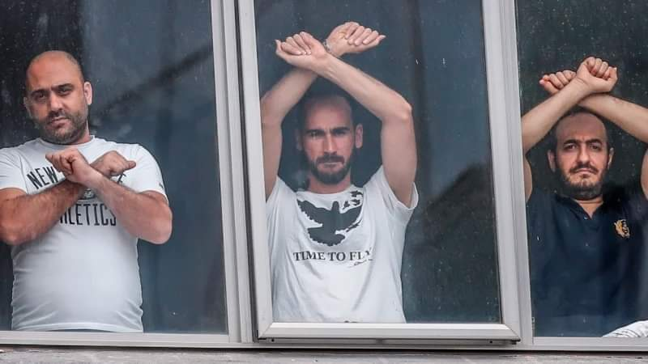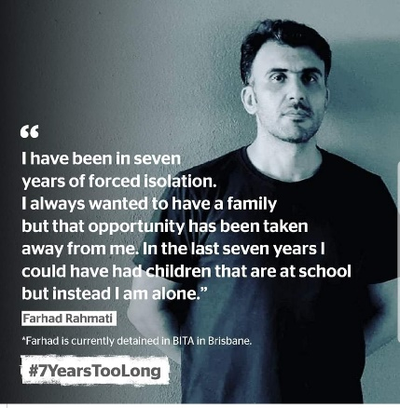

**FROM MORESBY to PRISON in HOTEL ROOMS or DETENTION CENTRES IN AUSTRALIA**

**How would we feel cooped up in a hotel room for ten months or more unable to move freely from the room or open a window?**

**140 refugees are being locked in hotels in both Melbourne and Brisbane after being brought to Australia under the repealed ‘medivac’ law.**

Medivaced from PNG and Nauru are imprisoned in Detention Centres mainly in BITA in Brisbane or MITA in Melbourne. A few have been arbitrarily moved away from friends to other places like Adelaide. Locked up without access to fresh air, windows remain closed, sometimes four to a room, must stay on the one hotel floor, man handled and held in escort as they are taken to a rare medical appointment.

LITTLE support has been given to avoid the COVID19 virus and a guard has already tested positive.   
**LIES of the government.**

Trudge recently said many men had refused medical treatment. This is blatantly not true. Some have refused to have their teeth pulled out- the only option offered to men with a mouth full of rotting teeth causing gum and stomach problems. There is no special diet so they try to eat the softer of the meagre foods in each meant and I believe one man has only fed from a straw for over a year now. Many have been told they have to wait for years for surgery. A few are too traumatised to accept being handcuffed and man handled and taken like prisoners to medical appointments when they know they will not get the treatment they need.

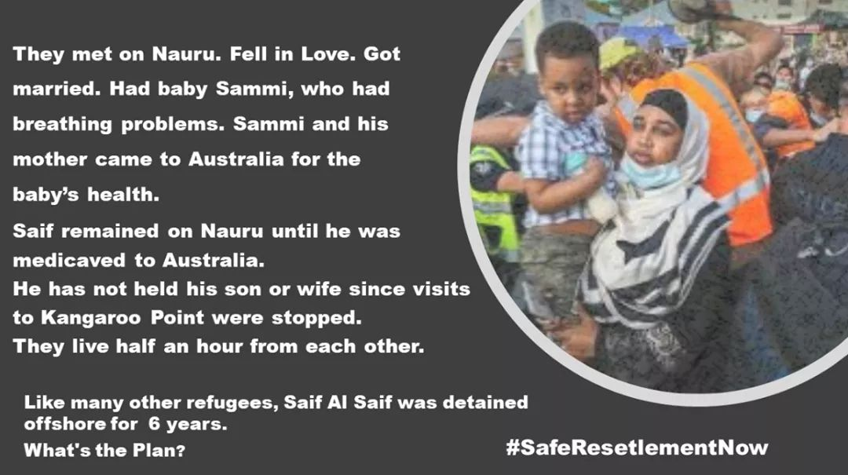

|  |  |
| --- | --- |
| **US Resettlement**  702 people from Manus and Nauru have accepted US visas and it is expected the program will end late September. Meanwhile about 40 men in PNG wait with no answer as to whether they have been accepted or not. Some have waited for nearly a year now. To keep people in such uncertainty is cruel.In the US some are doing well and we hear from them regularly. Naeem sends his love and thanks on behalf of a groups of Pakistanis in Philadelphia . Some drive road trains across the US and make good money. Others earn a miserable basic wage working for places like Walmart and are barely surviving. Covid19 has made it very difficult and AdsUp, a group of Aussi expats tries to help. Wahid, whom Canberra people supported in Manus for years is a recent arrival and arrived at just the wrong time. He is desperate and we are trying to help him raise $3500 to train to drive the road trains so he can feed himself. Contact Jane if you want to help him.  **Other facts:**  **There are 30,000 refugees living in community without permanent visas.**  There are more than 16,000 children and young people seeking asylum in Australia, and their families are ineligible  for JobKeeper, JobSeeker and Medicare.  There are 845 people in Community Detention around the country (this includes 284 children).  US Deal: 702 people have accepted USA visas. It is expected that only a few more will be accepted now. | **BEYOND CRUELTY**  Since 2001 Australians have become conditioned by the LNP and its partner the Murdoch media and by the lack of backbone of an often complicit Labor Party  to believe that REFUGEES:  *arrived illegally  *are not people with normal human rights  *would be able to live safely back home  *can be locked up without charge or trial  *don’t deserve fair treatment  *can be slowly punished, tortured beyond recovery without raising concerns  *don’t deserve fair treatment  *are a danger to Australian wellbeing or jobs  *don’t deserve appropriate medical treatment  *are criminals deserving only of punishment  * need to be handcuffed when being taken to an appointment  *need to be body searched or pat searched often  *can be kept denied access to their children  * can be lied about and vilified with impunity  *should be denied access to phones  *are not people we should care about  *should not be given access to education or training if they missed out back home  * should be denied recognition of previous qualifications, education, skills or expertise  * are not worthy of jobkeeper or jobseeker and can be left out in the streets without support  It is worth paying $350,000 per person per year to keep them away from sight on foreign tropical islands or in inaccessible prisons  THEY ARE NOT PEROPLE JUST LIKE US  THIS IS APARTHEID - AUSTRALIA |